Activity
Match the paintings with the titles
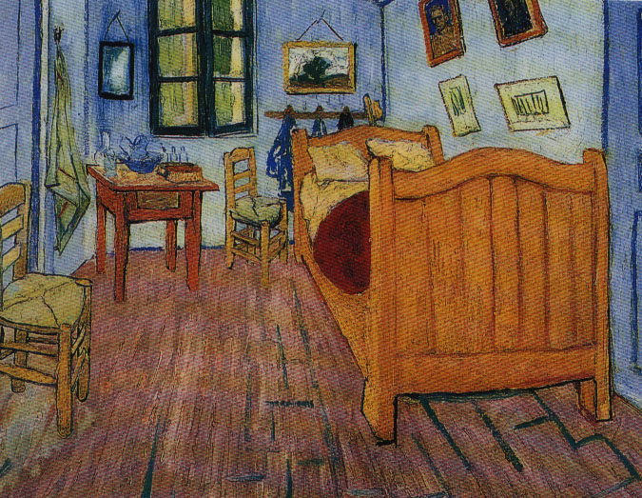  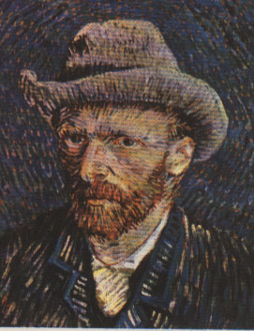  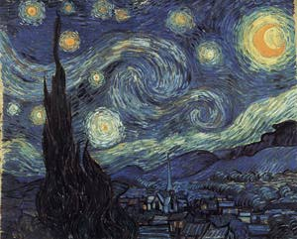  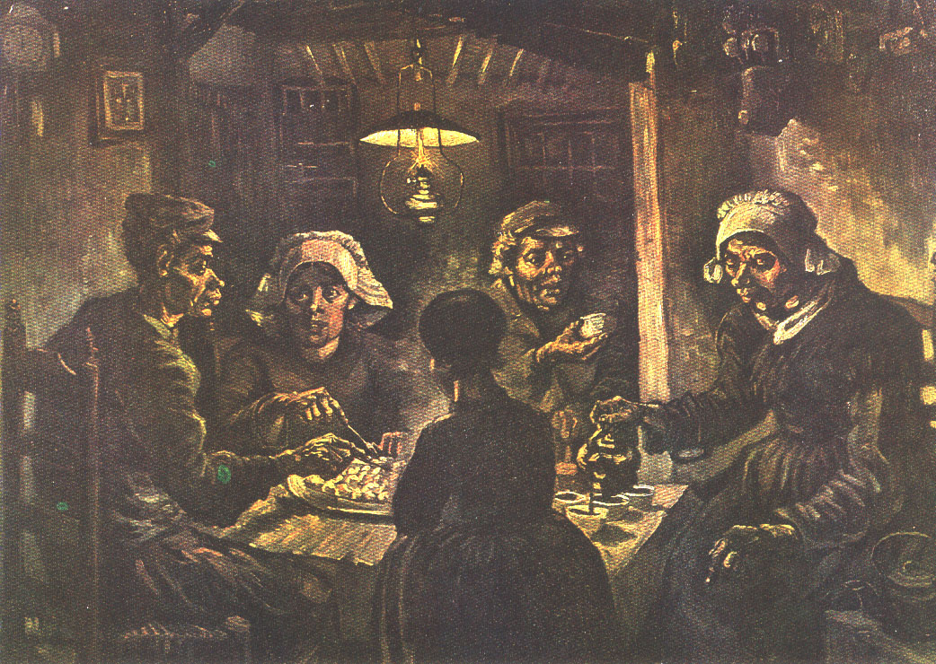  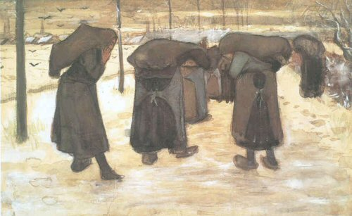 | *The self-portrait with  the felt hat  *The Potato Eaters  *The bedroom at Arles  *Miners’wives carrying  sacks of coal  *The Starry Night

